**TP Registration Details**

<Display the TP Registration in view mode as submitted by the TP during registration in separate tab>

**Organization Profile**

The sections will be as shown in the screen shot.

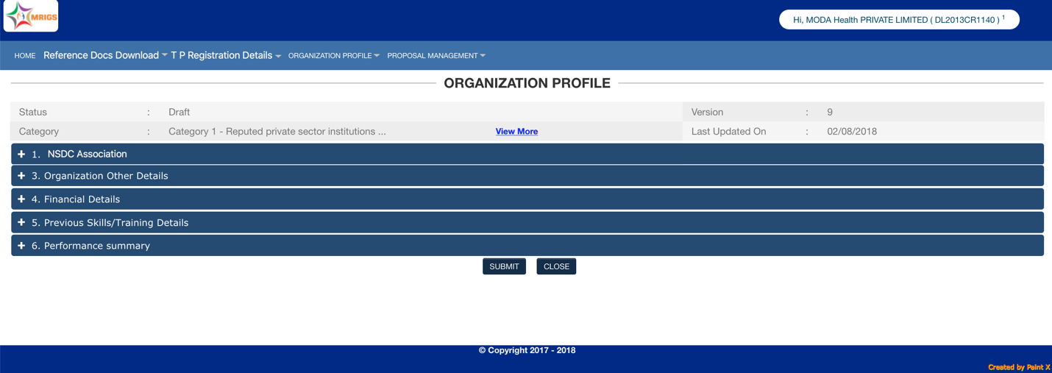

First 1 to 3 category will be determined by legal nature of the entity (TP Registration). If the Applicant organization has done any training in PMKVY (not under NSDC Partnership), the category will change to Cat 4 and hence the documentation as well.

**1. NSDC Association**

* 1. Are you NSDC Partner (Funded/ Non-Funded) <Yes/ No>

If Yes,

Upload Agreement document: <upload document>

Upload Self Declaration of NSDC Partnership: <upload document>

* 1. Have you completed any training under PMKVY till 15th April 2018?

If Yes,

TP SDMS Code <user Input>

Display TP Name, TP SPOC Name, TP SPOC Mobile Number, PT SPOC Email id (from the base data provided by NSDC)

If the TP SDMS code is not found, display message “No such TP SDMS code exists, check the code entered by you.”

Ask for confirmation of the details displayed

<Save & Proceed> <Close>

On save and proceed, display message that “If you change the NSDC Association parameter subsequently, the information furnished in subsequent tabs may be reset.”

After the user proceeds, and answer to 1.2 is “Yes”, the category of the applicant organization will be changed to Category 4. Status is updated on the top information bar.

**2. Organization Other Details**

2.1 Do the applicant PIA included in the First Threshold of the PMKVY monitoring Penalty Grid? <Yes/ No>

2.2The organization been blacklisted by central of state governments or any other agency? <Yes/ No>

2.3.1 Are you an academic institution: <Yes/ No>

2.3.2 If yes, upload the certification of Affiliation with the university Or Certificate of registration/affiliation with DGET/NCVT (Maximum 1 year old): <upload>

2.4.1 Are you an Philanthropic Organization: <Yes/ No>

2.4.2 If Yes, attach Publication from an unrelated third party in public domain in the last 3 years before 31st March 2018: <Upload>

2.5 Do the applicant PIA have a compliance manual?

2.6 Do the applicant PIA have a manual detailing standards operating procedure for training activities?

**3. Financial Details**

This tab is dependent on the Category of the organization (due to Govt Organizations, which do not always have CA audited financials)

3.1 Financials Parameters

Cat 1

|  |  |  |  |  |  |  |  |  |  |  |  |
| --- | --- | --- | --- | --- | --- | --- | --- | --- | --- | --- | --- |
| **Financial Year** | **Income (in Rs.)** | **Expenditure (in Rs.)** | **Name of the Officer** | **Employee no** | **Designation** | **Contact No.** | **Email Id** | **IT Returns Filed** | **ITR Acknowledgement Number** | **ITR Acknowledgement document upload** | **Certificate of IE** |
| **1** | **2** | **3** | **4** | **5** | **6** | **7** | **8** | **9** | **10** | **11** | **12** |
| 2017-2018 |  |  |  |  |  |  |  | <Y/N> |  |  | <upload> |
| 2016-2017 |  |  |  |  |  |  |  |  |  |  |  |
| 2015-2016 |  |  |  |  |  |  |  |  |  |  |  |

|  |  |  |
| --- | --- | --- |
| **Average Expenditure done over last three Financial Years (in Rs.):** |  |  |

Cat 2, 3 & 4

|  |  |  |  |  |  |  |  |  |  |  |  |  |  |  |
| --- | --- | --- | --- | --- | --- | --- | --- | --- | --- | --- | --- | --- | --- | --- |
| **Financial Year** | **Annual Turnover (in Rs.)** | **Net worth (in Rs.)** | **Debt-Equity Ratio** | **Donation/ Funding** | **Name of the Statutory Audit Firm** | **Name of Statutory Auditor** | **CA membership No.** | **Contact No.** | **Email Id** | **Audited / Not-audited** | **Statutory Auditor Certificate ... View More** | **IT Returns Filed** | **ITR Acknowledgement Number** | **ITR Acknowledgement document upload** |
| **1** | **2** | **3** | **4** | **5** | **6** | **7** | **8** | **9** | **10** | **11** | **12** | **13** | **14** | **15** |
| 2017-2018 |  |  |  |  |  |  |  |  |  |  |  | <Y/N> |  |  |
| 2016-2017 |  |  |  |  |  |  |  |  |  |  |  |  |  |  |
| 2015-2016 |  |  |  |  |  |  |  |  |  |  |  |  |  |  |

|  |  |  |
| --- | --- | --- |
| **Average Annual Turnover for last three "Audited" financial Years (in Rs.):** |  |  |

Net worth of the organization as on March 31, 2018: <display>

Average Donation/Funding done in past 3 years: <display>

3.2 CIBIL Report of the Applicant Entity from TransUnion CIBIL: <upload>

[mandatory in case of Cat 3 (out of initial category of 1, 2, and 3). i.e., even if the applicant entity is in Cat 4 but it was in cat 3 initially at the time of TP Registration, this will be mandatory]

3.3 Is any statutory dues pending at the time of application? <yes/ No> <upload Statutory Auditor Certificate>

**4. SKILLING EXPERIENCE**

**5.1 Details of Closed/ Foreclosed/Ongoing Projects [Only projects in which Actual training has been completed and placement provided between April 1, 2015 till March 31, 2018]**

4. Type of Project * <PMKVY(STAR) Central Component Scheme/ PMKVY State Component Scheme/ PMKK/ NSDC Partnership/ Govt Projects/ Private Projects>

5. Name of Client * <for PMKVY(STAR) Central Component Scheme/ PMKK/ NSDC Partnership, mandatorily NSDC>

1. Contract no./Work Order no./Sanction no./Affiliation No. * (not required for PMKVY/STAR/PMKK and Private Projects)

2. Date of Sanction * (not required for PMKVY(STAR) Central Component Scheme/ Private Projects)

3.Upload Sanction order / Reference Details * (not required for PMKVY(STAR) Central Component Scheme/ Private Projects)

6. Project cost (in Rs.) * (not required for PMKVY/STAR/PMKK)

Project Period From <date> To <date> (not required for PMKVY/STAR/PMKK)

7. Duration (months) * calculate

8. Project status * (not required for PMKVY/STAR/PMKK)

9. Training Target *

10. Total Candidates Trained *

11. Total Candidates Placed (formal Employment) *

Total Candidates Self Employed*

Total Candidates NAPS

12. Date at which provided Training/Placement figures have been Achieved * <current date>

13. Documentary evidence for Ongoing Project / Screenshot of Project Website/ Self Declaration for NSDC Partnership * (not required for PMKVY/STAR and Private Projects)

14.Upload Project Closure Certificate (not required for PMKVY/STAR and Private Projects)

15.Was the project executed as Consortium * (not required for PMKVY/STAR and Private Projects)

5.1.1 Financial Year Wise Skilling and Placement Experience

|  |  |  |  |  |  |  |
| --- | --- | --- | --- | --- | --- | --- |
| FY Year (2015-16/ 2016-17/ 2017-18) | Training Target (only for PMKVY/ STAR/ PMKK) | Total Trained | Total Placed | Total Self Employed | Total NAPS | Not provided any type of employment |
|  |  |  |  |  |  |  |
| Total |  |  |  |  |  |  |

Note:

The total of trained and placed/ self-employed/ NAPS should be either less than or equal to the figures provided above.

Total Placed + Total self-employed + Total NAPS + Total Not provided any type of employment = Total Trained

#### 5.1.2 Trade-wise Skilling Experience details

|  |  |  |  |  |  |  |
| --- | --- | --- | --- | --- | --- | --- |
| Sector | Trade | Training Target (only for PMKVY/ STAR/ PMKK) | Total Trained | Total Placed | Total Self Employed | Total NAPS |
|  |  |  |  |  |  |  |
| Total |  |  |  |  |  |  |

Note:

1. For PMKVY/ Star/ PMKK/ NSDC Partnership, only SSC trades should be visible including those that have retired. For all other type of projects, MES courses should be selectable (the current list)
2. The total of trained/ placed/ self-employed/ NAPS should equal to the figures quoted in 5.1.1